**13. Kubernetes Deployment – Introduction**

--- **note** – deployment is superset of replicaset which means, it will provide more features then replicaset. There is no difference in accessing the application hosted by replicaset. The both replicaset and deployment will use the service concept.

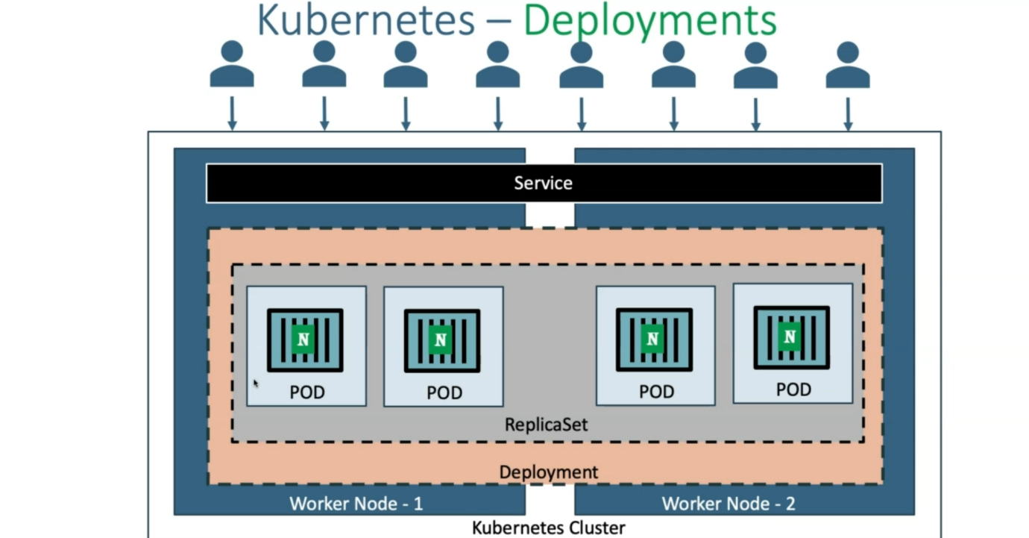

**What are the deployment features available?**

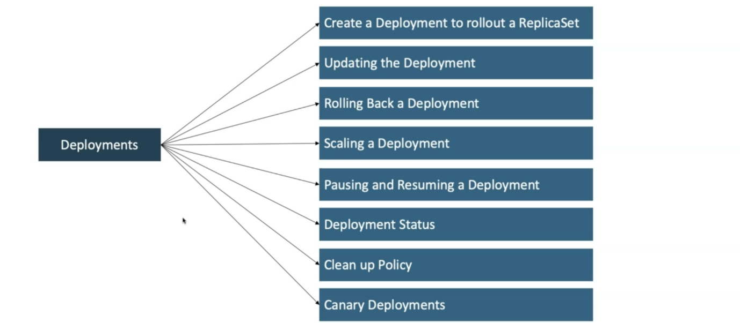

--- **create a deployment to rollout a replicaset** – by default whenever we created a deployment, a replicaset will be rolled out.

--- **updating the deployment** – whenever we want to change our application version or update our application, when we do update it will record our deployments.

--- **Rolling back a deployment** – we can easily go back to older deployment because deployment will record the all the deployments.

--- **scaling a deployment** – we will also able to scale our deployment, how we done scaling in the replicaset, in the same way will do the scaling in deployments.

--- **pausing and resuming a deployment** - you can pause your deployment when you want to apply multiple changes.

--- **deployment status** – whenever your do the deployment, you can see the roll out status and deployment status.

--- **clean up policy** – whenever we do the updating of your deployment, it maintains roll out history, by default it maintains 10 versions of our application.

--- **canary deployments** – if you want to add new version of our application in the live production traffic and the traffic should be distributed between old version and new version. This can be done by canary deployment.

--- **note** – all these things is available for deployments.